Objectives

1.Explain React components
React components are reusable building blocks used to create parts of a user interface. Each component returns JSX that React renders on the screen.
2.Identify the differences between components and JavaScript functions
React Component | JavaScript Function
Returns JSX (UI) | Returns data or values
Used to build interfaces | Used for general programming tasks
Can receive props | Accepts parameters
Managed by React | Managed by JavaScript

3.Identify the types of components
Function Components ,Class Components
4.Explain class component
A class component is created using the class keyword and extends React.Component. It uses a render() method to display JSX and can manage state and lifecycle methods.
5.Explain function component
A function component is a JavaScript function that returns JSX. It is simpler than a class component and is the preferred approach in modern React.
6.Define component constructor
A constructor is a special method in a class component used to initialize state and bind methods. It runs when the component is created.
7.Define render() function
The render() function is required in class components. It returns the JSX that React displays in the browser.

In this hands-on lab, you will learn how to:
- Create a class component
- Create multiple components
- Render a component

Prerequisites

The following is required to complete this hands-on lab:
- Node.js
- NPM
- Visual Studio Code

Notes

Estimated time to complete this lab: 30 minutes.

Create a react app for Student Management Portal named StudentApp and create a component named Home which will display the Message “Welcome to the Home page of Student Management Portal”. Create another component named About and display the Message “Welcome to the About page of the Student Management Portal”. Create a third component named Contact and display the Message “Welcome to the Contact page of the Student Management Portal”. Call all the three components.

- Create a React project named “StudentApp” type the following command in terminal of Visual studio:

- Create a new folder under Src folder with the name “Components”. Add a new file named “Home.js”

- Type the following code in Home.js

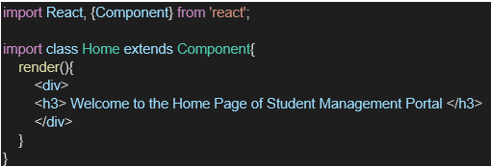

- Under Src folder add another file named “About.js”

- Repeat the same steps for Creating “About” and “Contact” component by adding a new file as ”About.js”, “Contact.js” under “Src” folder and edit the code as mentioned for “Home” Component.

- Edit the App.js to invoke the Home, About and Contact component as follows:

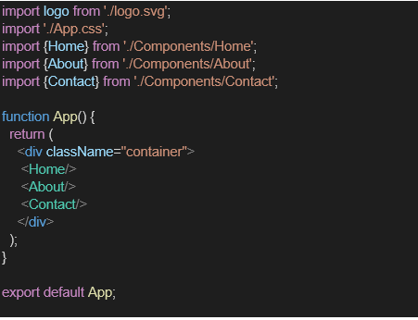

- In command Prompt, navigate into StudentApp and execute the code by typing the following command:

- Open browser and type “localhost:3000” in the address bar:

